**Docker Engine installation in Ubuntu using convenience script**

* To run the script root or sudo privileges are required. Switch from normal user to root user by running the command – **sudo -i**. Give the password to login.



* The content of the file/script docker.sh will be available in the following URL <https://get.docker.com/>
* Curl the file using the command -

**curl -fsSL https://test.docker.com -o test-docker.sh.** Check the list availability using **ls** command.

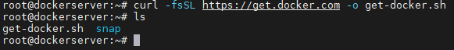

* To execute the file/script run the command **sh get-docker.sh**. The file/script takes care of running the apt-get update command, installing minimum pre-requisite packages, creating a repository, downloading the GPG key and then running the apt update command and finally installing the docker engine packages.

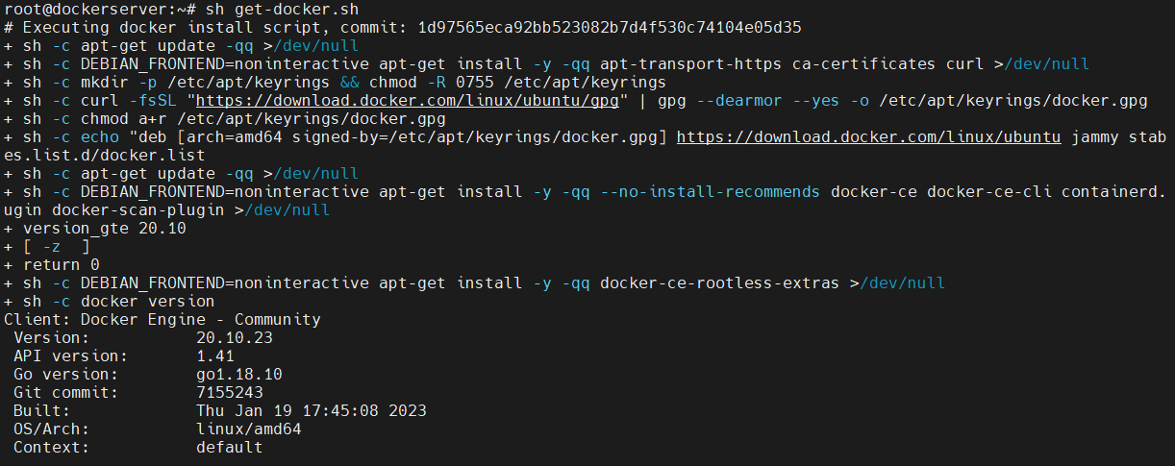

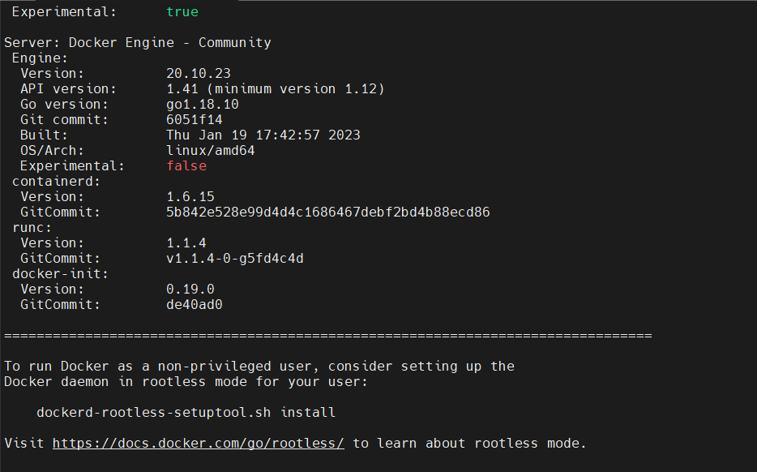

* The script installs only latest version packages. To install specified version, use other Docker Engine installation methods.
* To verify the installation & Version of Docker Engine run the command **docker --version**.

